Experiment-3
Aim
To read an image using Python and OpenCV and detect the edges or outline of the image using the Canny edge detection technique.
Procedure
- Import the OpenCV library.
- Read the input image.
- Convert the image into gray-scale.
- Apply the Canny edge detection function.
- Display the original and edge-detected images.
Code
import cv2

img = cv2.imread(r"C:\Users\VARSHINI\Downloads\sample image.png")

if img is None:
print("Image not found!")
exit()

gray = cv2.cvtColor(img, cv2.COLOR_BGR2GRAY)

edges = cv2.Canny(gray, 100, 200)

cv2.imshow("Original Image", img)
cv2.imshow("Canny Edge Image", edges)

cv2.waitKey(0)
cv2.destroyAllWindows()
Sample Input
Input: r"C:\Users\VARSHINI\Downloads\sample image.png"
— a color image containing objects or shapes.
Sample Output
- Original image

- Image showing the outlines/edges of objects
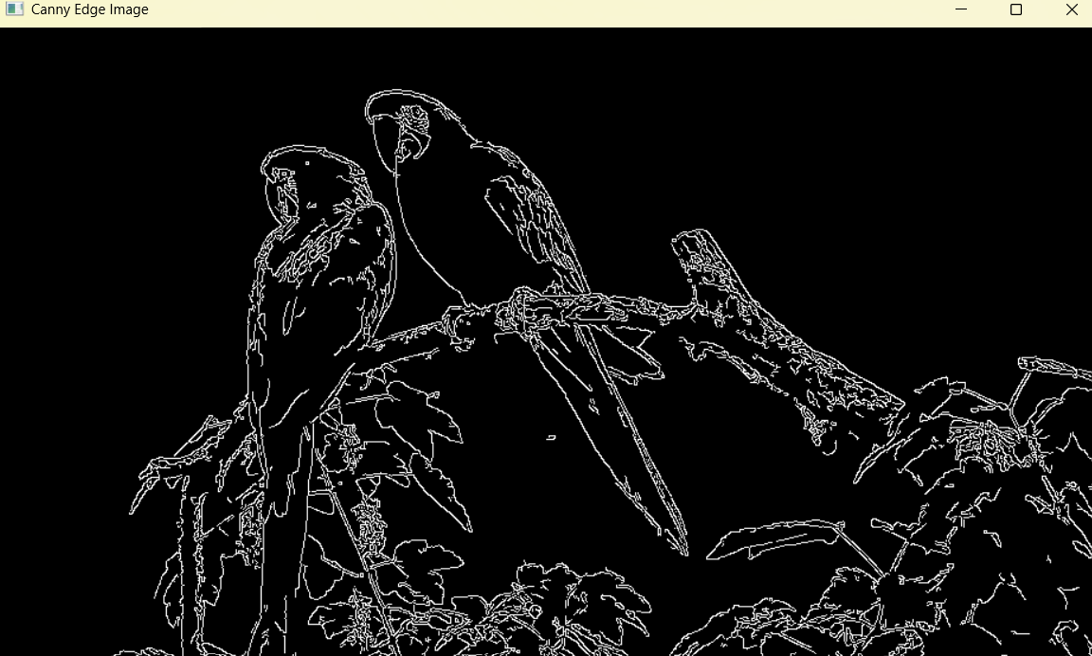
Result
Thus, the outlines of the objects in the given image were successfully detected using the Canny edge detection function in OpenCV.

